**SCRIPTED PIPELINE (LAB 7)**

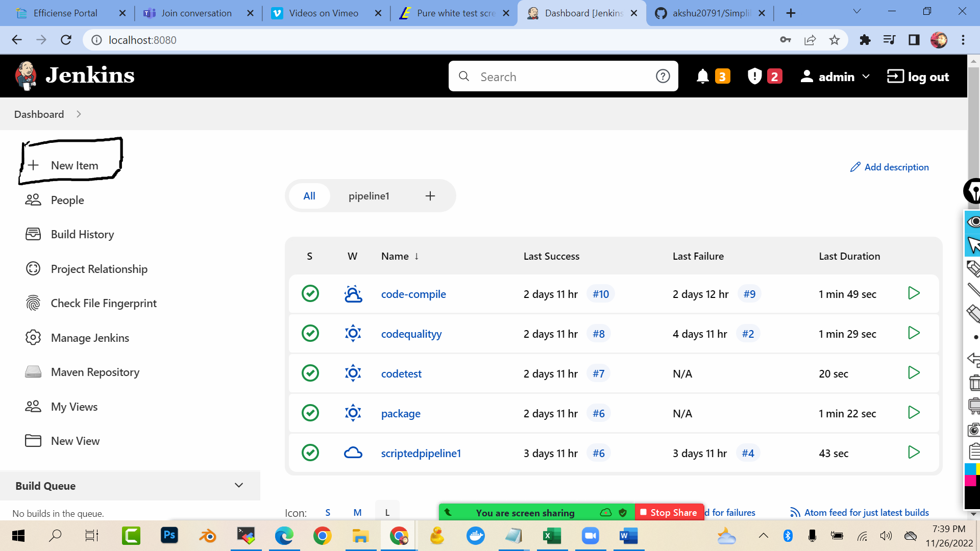

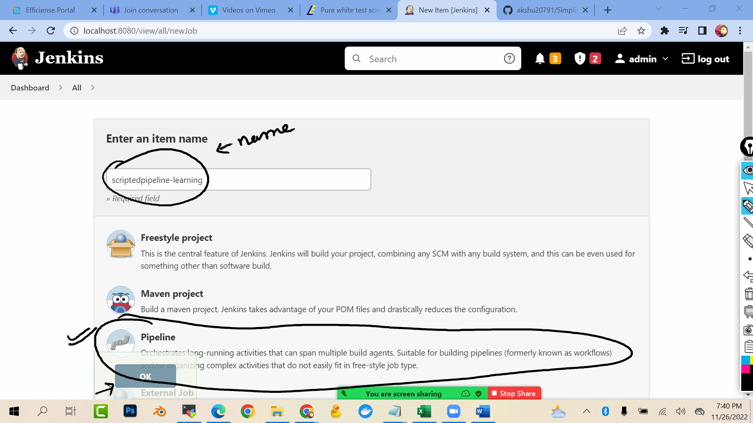

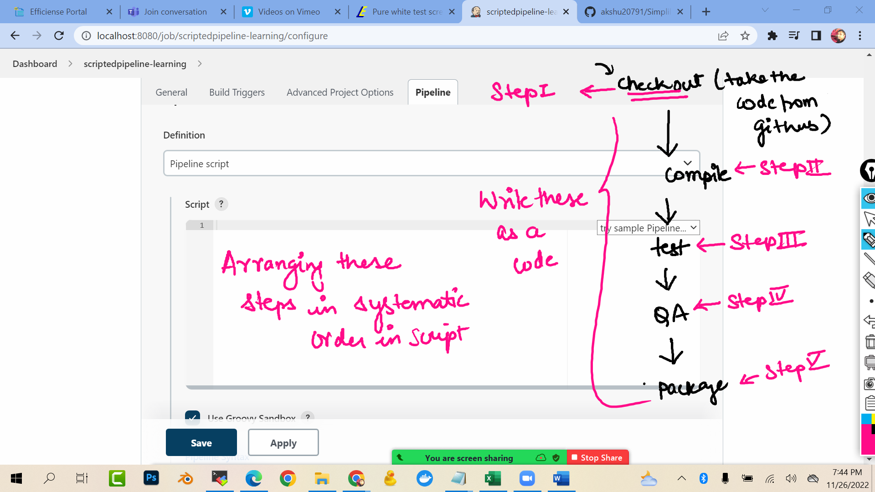

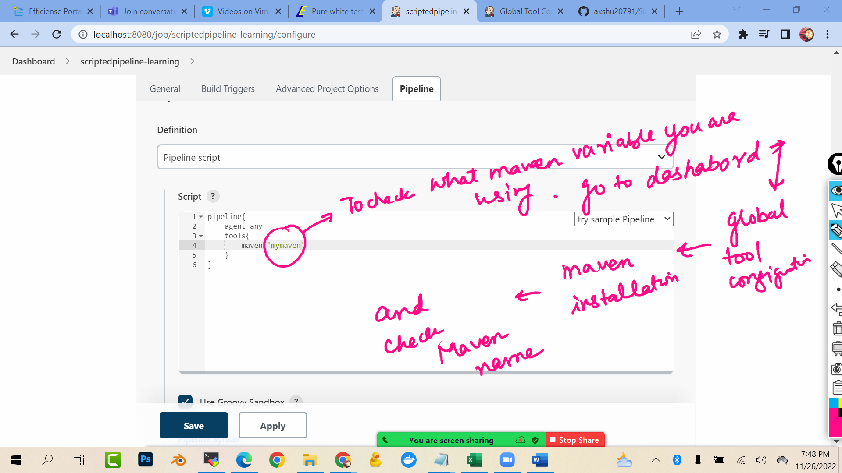

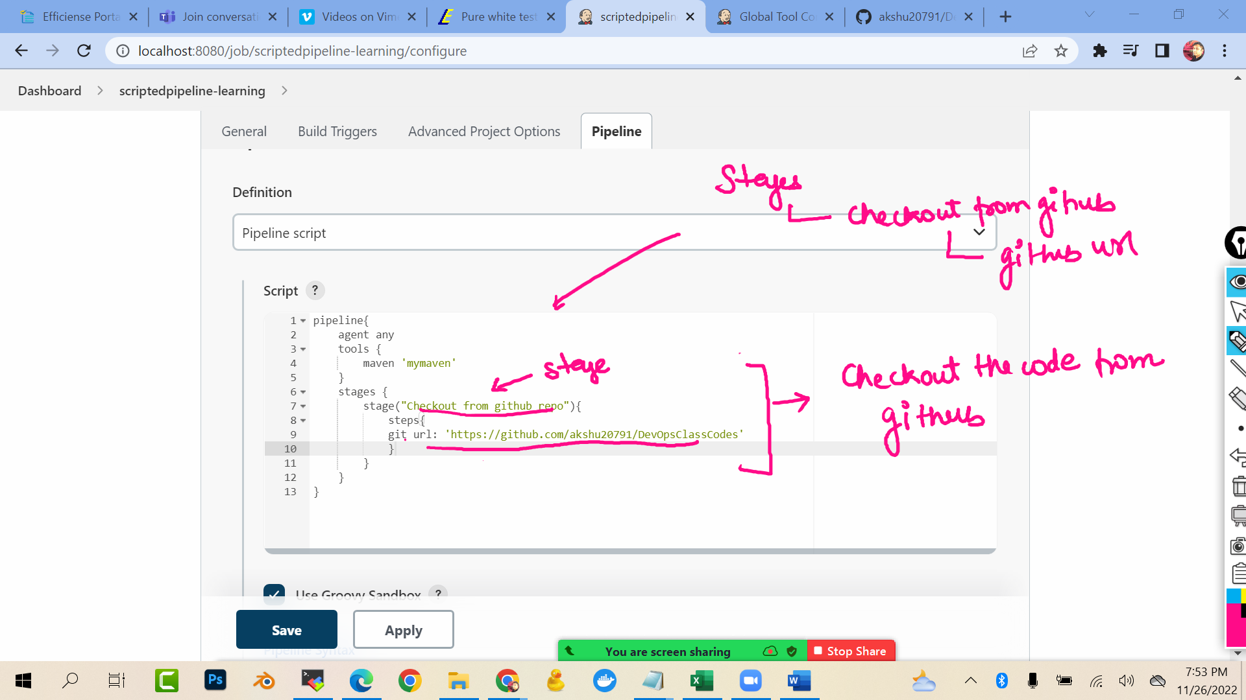

pipeline{

agent any

tools {

maven 'mymaven'

}

stages {

stage("Checkout from github repo"){

steps{

git url: 'https://github.com/akshu20791/DevOpsClassCodes'

}

}

}

}

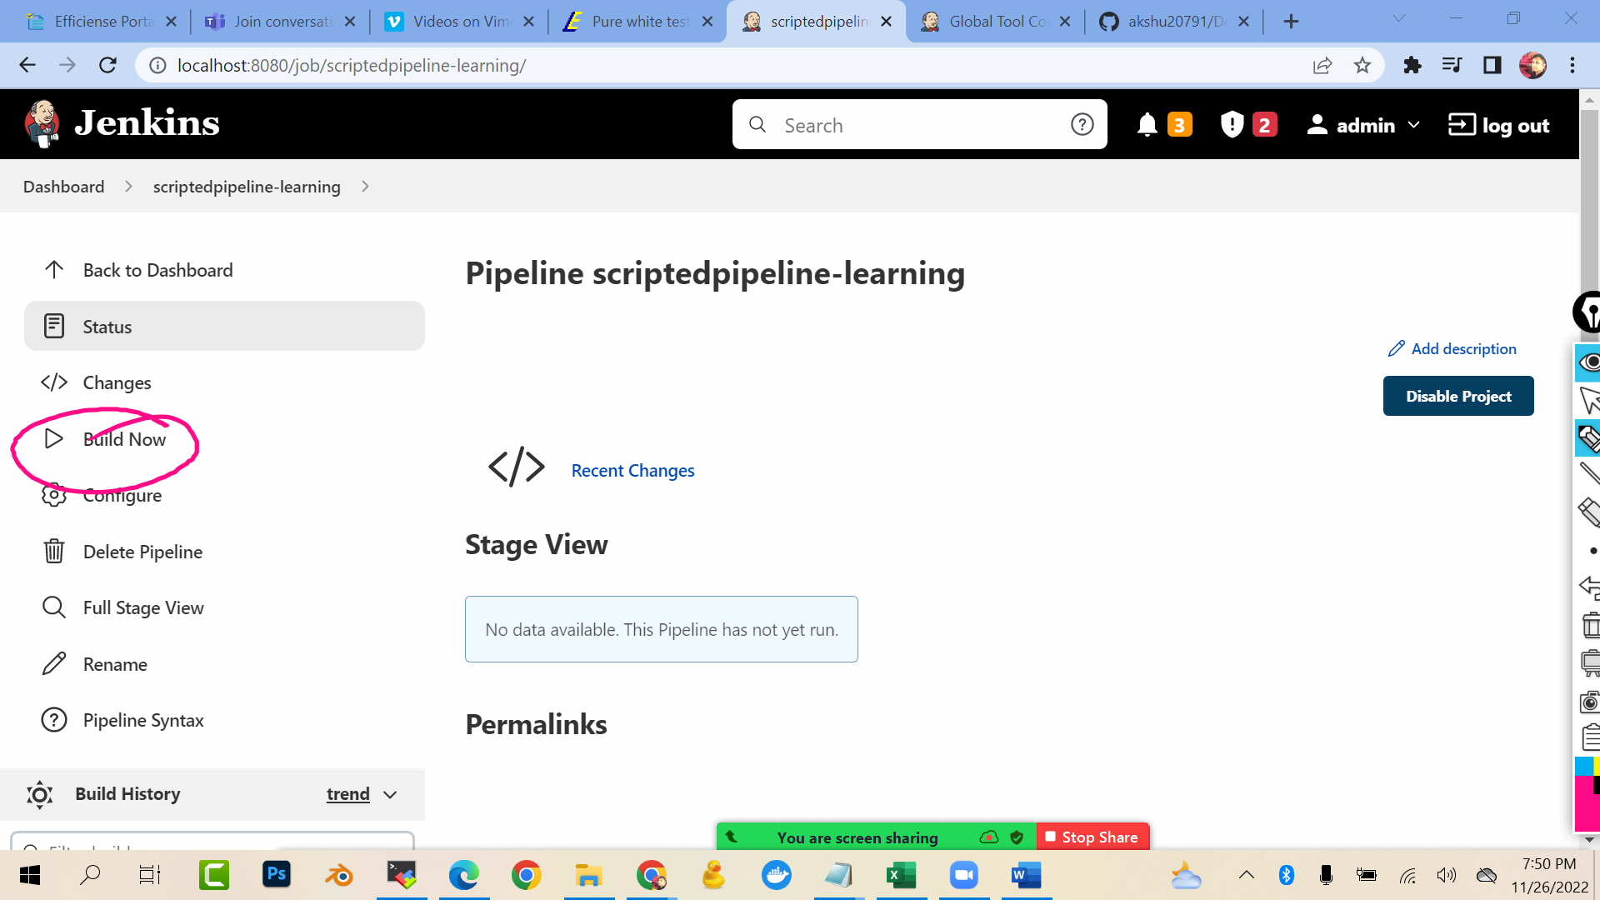

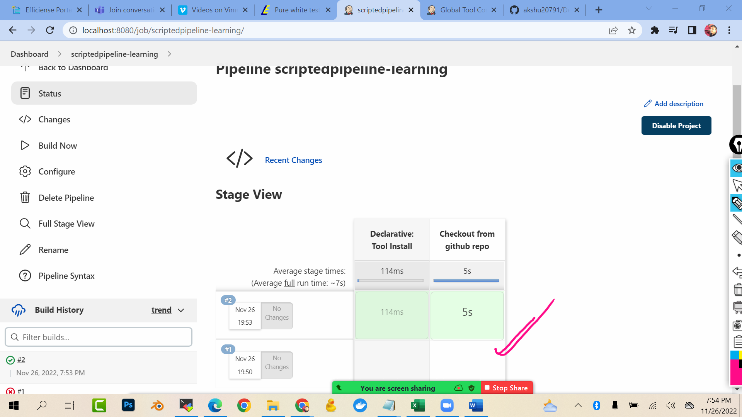

[;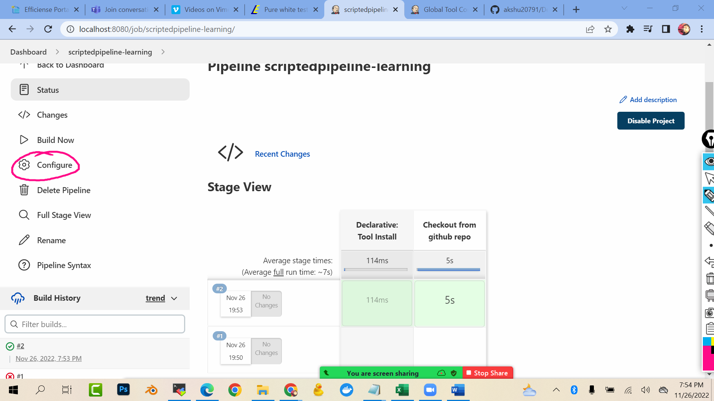

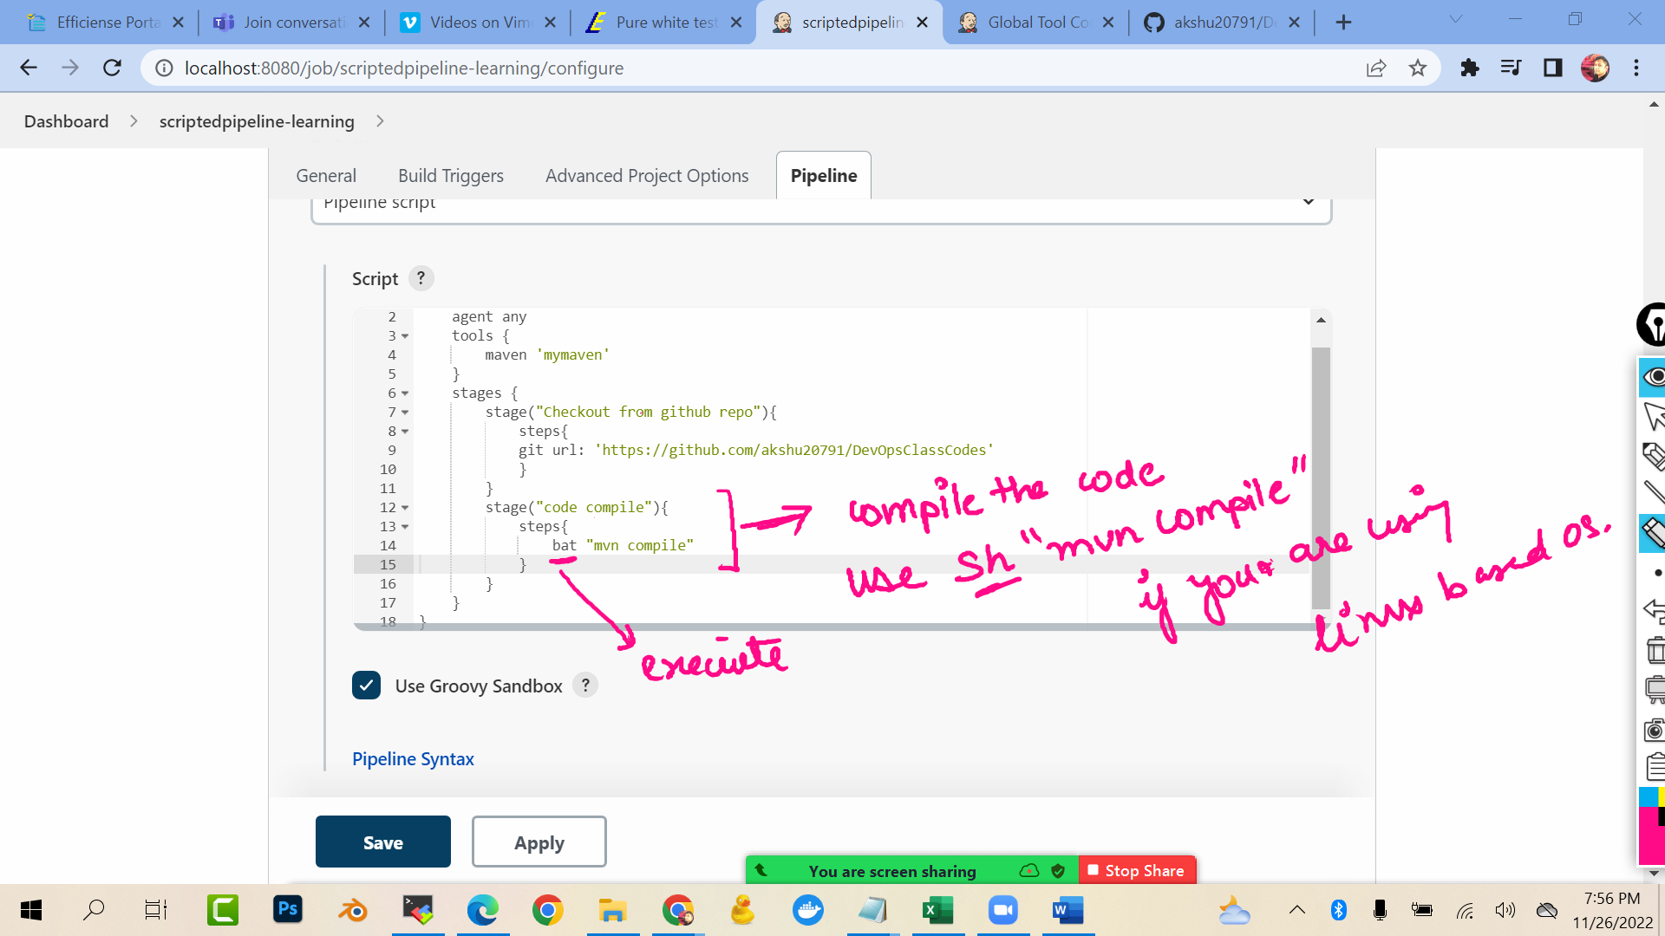

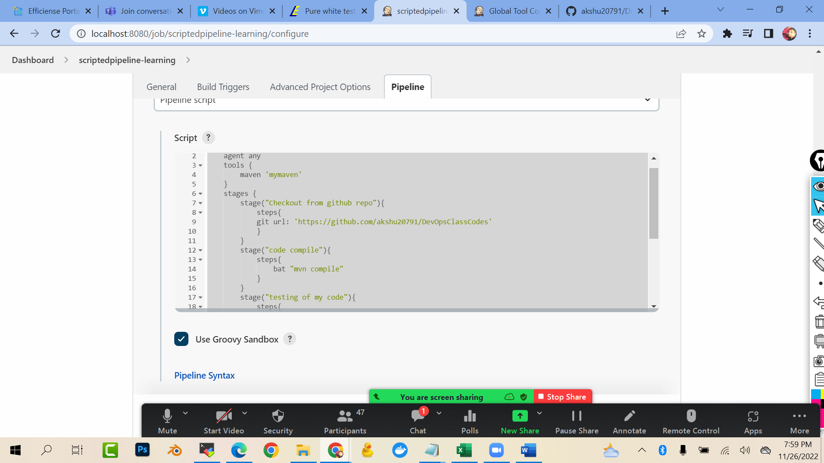

pipeline{

agent any

tools {

maven 'mymaven'

}

stages {

stage("Checkout from github repo"){

steps{

git url: 'https://github.com/akshu20791/DevOpsClassCodes'

}

}

stage("code compile"){

steps{

bat "mvn compile"

}

}

stage("testing of my code"){

steps{

bat "mvn test"

}

}

stage("code quality check"){

steps{

bat "mvn pmd:pmd"

}

}

stage("package to be converted"){

steps{

bat "mvn package"

}

}

}

}

Save

